Django CRUD sturdent details..

Index.html, edit.html  
DB-**'crud_studentdjango' , workbench**

FORM manually crearted

D:\django\pythonProject\CRUD_django_student

<https://www.youtube.com/watch?v=Ko5KLX2n334&t=4807s>

ARK PRO CODER

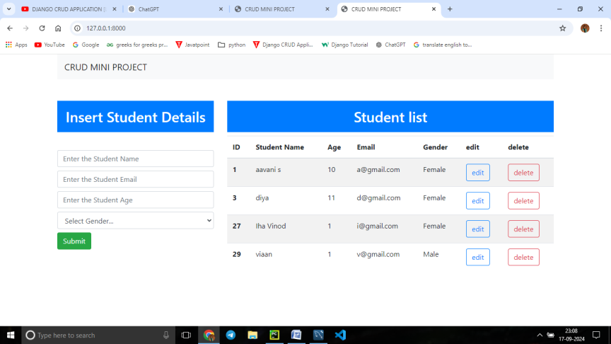index.html

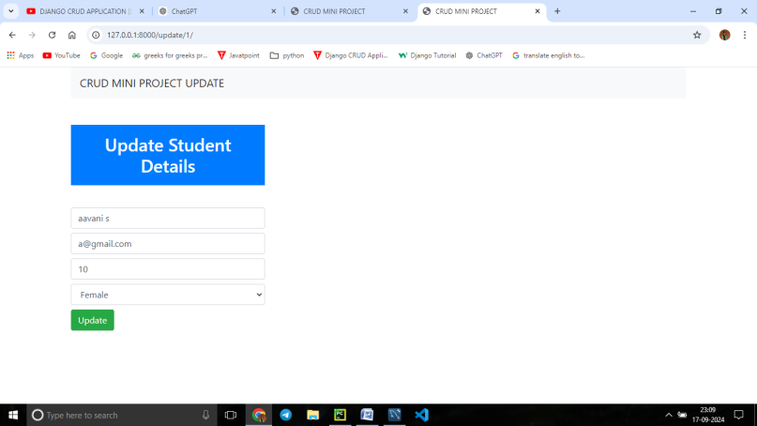Edit.html

Index.html

<!doctype html>  
<html lang="en">  
 <head>  
 <!-- Required meta tags -->  
 <meta charset="utf-8">  
 <meta name="viewport" content="width=device-width, initial-scale=1, shrink-to-fit=no">  
  
 <!-- Bootstrap CSS -->  
 <link rel="stylesheet" href="https://cdn.jsdelivr.net/npm/bootstrap@4.0.0/dist/css/bootstrap.min.css" integrity="sha384-Gn5384xqQ1aoWXA+058RXPxPg6fy4IWvTNh0E263XmFcJlSAwiGgFAW/dAiS6JXm" crossorigin="anonymous">  
  
 <title>CRUD MINI PROJECT</title>  
 </head>  
 <body>  
 <div class="container">  
 <nav class="navbar navbar-expand-lg navbar-light bg-light">  
 <a class="navbar-brand" href="/">CRUD MINI PROJECT</a>  
 </nav>  
</div>  
 <div class="container mt-5">  
 <div class="row">

<!—divide the page to two columns(col-md-4,col-md-8) -->  
 <div class="col-md-4 " > <!-- column 1 for inserting student details form-->  
 <h2 class="text-white bg-primary text-center p-3"> Insert Student Details</h2>  
 <br>

<!-- inserting details form starts here-->  
<!-- <form action="insert/" method="post">-->  
 <form action="{% url 'insertData' %}" method="post">  
 {% csrf_token %}

<div class="form-group"> <!-- manually form creating-->  
 <input type="text" class="form-control mt-2" placeholder="Enter the Student Name" name="name" required>  
 <input type="text" class="form-control mt-2" placeholder="Enter the Student Email" name="email" required>  
 <input type="number" class="form-control mt-2" placeholder="Enter the Student Age" name="age" required>  
  
 <div class="form-group ">  
<!-- <label for="gender">Gender </label>--> bootstrap copy  
 <select id="gender" class="form-control mt-2" name="gender" required>  
 <option selected>Select Gender...</option>  
 <option value="Male">Male</option>  
 <option value="Female">Female</option>  
 <option value="Others">Others</option>  
 </select>  
 <div class="d-grid gap-2 d-md-block">  
 <button class="btn btn-success mt-2" type="submit">Submit</button>  
 </div>  
 </div>  
  
 </div>  
 </div>  
 </form>  
 <div class="col-md-8"><!-- column 2 displaying inserted student detailas table table copied from bootsrap-->  
 <h2 class="text-center text-white bg-primary text-center p-3" > Student list</h2>  
<table class="table table-striped">  
 <thead>  
 <tr>  
 <th scope="col">ID</th>  
 <th scope="col">Student Name</th>  
 <th scope="col">Age</th>  
 <th scope="col">Email</th>  
 <th scope="col">Gender</th>  
  
 <th scope="col">edit</th>  
 <th scope="col">delete</th>  
 </tr>  
 </thead>  
 <tbody>  
 {% for d in data %}  
 <tr>  
 <th scope="row">{{d.id}}</th>  
 <td>{{d.name}}</td>  
 <td>{{d.age}}</td>  
 <td>{{d.email}}</td>  
 <td>{{d.gender}}</td>  
  
 <td><a href="/update/{{d.id}}" type="button" class="btn btn-outline-primary">edit</a></td>  
 <td><a type="button" href="/delete/{{d.id}}" class="btn btn-outline-danger">delete</a></td>  
 </tr>  
 {% endfor%}  
  
 </tbody>  
</table>  
  
 </div>  
  
 </div>  
  
 <script src="https://code.jquery.com/jquery-3.2.1.slim.min.js" integrity="sha384-KJ3o2DKtIkvYIK3UENzmM7KCkRr/rE9/Qpg6aAZGJwFDMVNA/GpGFF93hXpG5KkN" crossorigin="anonymous"></script>  
 <script src="https://cdn.jsdelivr.net/npm/popper.js@1.12.9/dist/umd/popper.min.js" integrity="sha384-ApNbgh9B+Y1QKtv3Rn7W3mgPxhU9K/ScQsAP7hUibX39j7fakFPskvXusvfa0b4Q" crossorigin="anonymous"></script>  
 <script src="https://cdn.jsdelivr.net/npm/bootstrap@4.0.0/dist/js/bootstrap.min.js" integrity="sha384-JZR6Spejh4U02d8jOt6vLEHfe/JQGiRRSQQxSfFWpi1MquVdAyjUar5+76PVCmYl" crossorigin="anonymous"></script>  
 </body>  
</html>

Edit.html (just copy the index.html page amd make changes )

<!doctype html>  
<html lang="en">  
 <head>  
 <!-- Required meta tags -->  
 <meta charset="utf-8">  
 <meta name="viewport" content="width=device-width, initial-scale=1, shrink-to-fit=no">  
  
 <!-- Bootstrap CSS -->  
 <link rel="stylesheet" href="https://cdn.jsdelivr.net/npm/bootstrap@4.0.0/dist/css/bootstrap.min.css" integrity="sha384-Gn5384xqQ1aoWXA+058RXPxPg6fy4IWvTNh0E263XmFcJlSAwiGgFAW/dAiS6JXm" crossorigin="anonymous">  
  
 <title>CRUD MINI PROJECT</title>  
 </head>  
 <body>  
 <div class="container">

<!—copy navbar from bootstrap-->  
 <nav class="navbar navbar-expand-lg navbar-light bg-light">  
 <a class="navbar-brand" href="/">CRUD MINI PROJECT UPDATE</a>  
 </nav>  
</div>  
 <div class="container mt-5">  
 <div class="row">  
 <div class="col-md-4 " > <!-- column 1 for inserting student details form-->  
 <h2 class="text-white bg-primary text-center p-3"> Update Student Details</h2>  
 <br>  
<!-- inserting details form starts here-->  
 <!--<form action="insert/" method="post">-->  
 <form action="{% url 'updateData' d.id %}" method="post">  
 {% csrf_token %}  
  
 <div class="form-group"> <!-- manually form creating-->  
 <input type="text"  
 class="form-control mt-2"  
 placeholder="Enter the Student Name"  
 value="{{d.name}}"  
 name="name"  
 required>  
 <input type="text"  
 class="form-control mt-2"  
 placeholder="Enter the Student Email"  
 value="{{d.email}}"  
 name="email"  
 required>  
 <input type="number"  
 class="form-control mt-2"  
 placeholder="Enter the Student Age"  
 value="{{d.age}}"  
 name="age"  
 required>  
<!--<label for="gender">Gender </label>-->  
 <div class="form-group ">  
 <select id="gender"  
 class="form-control mt-2"  
 value="{{d.gender}}"  
 name="gender"  
 required>  
 <option selected>{{d.gender}}</option>  
 <option value="Male">Male</option>  
 <option value="Female">Female</option>  
 <option value="Others">Others</option>  
 </select>  
 <div class="d-grid gap-2 d-md-block">  
 <button class="btn btn-success mt-2" type="submit">Update</button>  
 </div>  
 </div>  
  
 </div>  
 </div>  
 </form>  
  
 </div>  
</div>  
 <script src="https://code.jquery.com/jquery-3.2.1.slim.min.js" integrity="sha384-KJ3o2DKtIkvYIK3UENzmM7KCkRr/rE9/Qpg6aAZGJwFDMVNA/GpGFF93hXpG5KkN" crossorigin="anonymous"></script>  
 <script src="https://cdn.jsdelivr.net/npm/popper.js@1.12.9/dist/umd/popper.min.js" integrity="sha384-ApNbgh9B+Y1QKtv3Rn7W3mgPxhU9K/ScQsAP7hUibX39j7fakFPskvXusvfa0b4Q" crossorigin="anonymous"></script>  
 <script src="https://cdn.jsdelivr.net/npm/bootstrap@4.0.0/dist/js/bootstrap.min.js" integrity="sha384-JZR6Spejh4U02d8jOt6vLEHfe/JQGiRRSQQxSfFWpi1MquVdAyjUar5+76PVCmYl" crossorigin="anonymous"></script>  
 </body>  
</html>

Views.py

from django.shortcuts import render,redirect  
  
from .models import Student  
# Create your views here.

# index fun load the index.html page and display the datas in the db  
def index(request):  
 data = Student.objects.all() # getting all the datas from db to 'data'  
 context = {**"data"**: data} # passing all the data into context in the form of dictionary  
 # print(context)  
 return render(request,**'index.html'**,context)  
  
def insertData(request):  
 data = Student.objects.all() # getting all the datas from db to 'data'  
 context = {**"data"**: data} # passing all the data into context in the form of dictionary  
 # print(context)  
# inserting data to db- Student  
 if request.method==**"POST"**:  
 name=request.POST.get(**'name'**)  
 email=request.POST.get(**'email'**)  
 age=request.POST.get(**'age'**)  
 gender=request.POST.get(**'gender'**)  
 # print(name)  
 query=Student(name=name, email=email, age=age, gender=gender)  
 query.save()  
 return redirect(**"/"**) # redirect to homepage, ie indexpage  
 return render(request, **'index.html'**, context)

def updateData(request,id):  
# inserting data to db Student

# first didplay the values in to the fields to edit  
 if request.method==**"POST"**:  
 name=request.POST[**'name'**]  
 email=request.POST.get(**'email'**)  
 age=request.POST.get(**'age'**)  
 gender=request.POST.get(**'gender'**)  
#to save the edited values into db to the corresponding id  
 edit=Student.objects.get(id=id)  
 edit.name=name  
 edit.email=email  
 edit.age=age  
 edit.gender=gender  
 edit.save()  
 return redirect(**"/"**)  
  
# display the data from the database base don seleated id  
 data= Student.objects.get(id=id) # getting all the datas from db to 'd'  
 # print(d)  
 context = {**"d"**: data} # passing all the data into context in the form of dictionary  
 # print(context)  
 return render(request,**'edit.html'**,context)  
  
def deleteData(request,id):  
 data=Student.objects.get(id=id)  
 data.delete()  
 return redirect(**"/"**)

Urls –pro

from django.contrib import admin  
from django.urls import path,include  
  
  
urlpatterns = [  
 path(**'admin/'**, admin.site.urls),  
 path(**''**,include(**'app_student.urls'**)),  
]

urls.py --app

from django.urls import path  
from app_student import views  
  
urlpatterns = [  
  
 path(**''**,views.index,name=**'index'**), # home page ie index.html  
 path(**'insert/'**,views.insertData,name=**'insertData'**),  
 path(**'update/<int:id>/'**,views.updateData, name=**'updateData'**),  
  
 path(**'delete/<int:id>/'**,views.deleteData, name = **'deleteData'**),  
  
]

admin.py

from django.contrib import admin  
from .models import Student  
# Register your models here.

admin.site.register(Student)

models.py

# crud_studentdjango ----db name workbench

from django.db import models  
  
# crud_studentdjango  
# Create your models here.  
class Student(models.Model):  
 # id=models.BigAutoField(primary_key=True)  
 name=models.CharField(max_length=25, blank=False,null=False)  
 email=models.EmailField()  
 age=models.IntegerField()  
 gender=models.CharField(max_length=25, blank=False,null=False)  
 def __str__(self):  
 return self.name # according to name table display

settings

INSTALLED_APPS = [  
   
 **'app_student'**,  
]

# Database  
# https://docs.djangoproject.com/en/5.1/ref/settings/#databases  
DATABASES = {  
 **'default'**: {  
 **'ENGINE'**: **'django.db.backends.mysql'**,  
 **'NAME'**: **'crud_studentdjango'**,  
 **'USER'**:**'root'**,  
 **'PASSWORD'**:**'3636'**,  
 **'HOST'**:**''**,  
 **'PORT'**:**''** }  
}

TEMPLATES = [  
 {  
 **'DIRS'**: [**'templates'**],   
 ],  
 },  
 },  
]

